Project 8: Configure a computer purchase
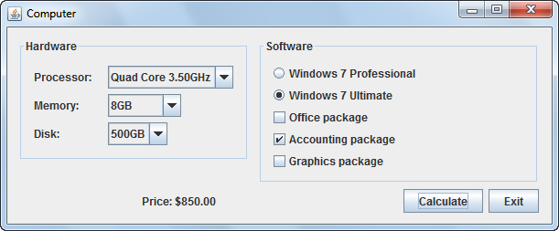

Operation
- The user configures the components of a computer system by selecting items from the combo boxes, radio buttons, and check boxes.
- When the user clicks the Calculate button, the application calculates the price of the system by adding the cost of each selected component to a base price.
- When the user closes the frame or presses the Exit button, the application exits.

Specifications
- The base price of the computer is $500.
- The user can select one of three processors:
Quad Core 3.40GHz included in base price
Quad Core 3.50GHz add $50.00
Quad Core 3.60GHz add $150
- The user can select one of four memory configurations:
4GB included in base price
8GB add $50.00
16GB add $100.00
32GB add $150.00
- The user can select one of three disk configurations:
500GB included in base price
1TB add $50.00
2TB add $150.00
- The user can select one of two operating systems:
Windows 7 Professional included in base price
Windows 7 Ultimate add $100.00
- The user can select any or all of the following three software packages:
Office package add $400.00
Accounting package add $200.00
Graphics package add $600.00

Hints
- Consider using a separate class to represent each of the configuration options.
- Don’t forget to include the base price ($500) when the program starts.

Enhancements
- Add a feature that indicates how changing each selection will affect the price. For example, if Windows 7 Ultimate is currently selected, change the text for the Windows 7 Professional label to “Windows 7 Professional (subtract $100).” However, if the Professional edition is currently selected, the check box for the Ultimate edition should read Windows 7 Ultimate (add $100).”
- Print a summary of the configuration to the console when the user clicks the Calculate button.
- If you’ve already covered file handling, retrieve the configuration options from a file rather than having them hard coded in the program.

